PROJECT REPORT

Wellness-AI

AI-Powered Health, Fitness & Wellness Assistant

Submitted by | PRATHEEKSHA N
Institution | Gandhi Institute of Technology and Management, Bangalore rural
SDG Alignment | SDG-3: Good Health and Well-Being
Date | June 2026

Table of Contents
Table of Contents 2
1. Executive Summary 3
2. Problem Statement 3
2.1 Impact of the Problem 3
3. Proposed Solution – WellnessAI 3
3.1 Key Features 4
3.2 Goal 4
4. Sustainability Connection……………………………………………………………………………..4
5. System Architecture 4
5.1 User Interface Layer 5
5.2 Application Layer 5
5.3 AI Wellness Engine (Core) 5
5.4 Use of IBM Technologies…………………………………………………………………………6
5.5 Data Layer 6
5.6 External Services 6
5.7 Security & Privacy Layer 6
6. Workflow 7
7. Prototype 9
7.1 Welcome / Home Screen 9
7.2 User Profile Screen 9
7.3 Fitness Goals Screen 9
7.4 AI Recommendation / Plan Screen 10
8. Responsible AI Considerations 11
9. Expected Impact 11
9.1 Individual Impact 11
9.2 Social Impact 11
10. Conclusion & Future Scope 11
10.1 Conclusion 11
10.2 Future Scope 11
11. Project Details 12

1. Executive Summary
Wellness-AI is an AI-powered health, fitness, and wellness assistant designed to help students and young adults build sustainable, healthy lifestyle habits. The system uses IBM Granite AI/ML models to analyze user profile, goal, and activity data, and in turn generates personalized workout plans, nutrition guidance, hydration and sleep recommendations, and an ongoing wellness score — all delivered through a simple mobile, web, or chat interface.
This report consolidates the project's architecture, end-to-end workflow, and interactive prototype into a single reference document. It covers the problem the project addresses, the proposed solution and key features, the underlying system architecture and data flow, the user-facing prototype screens, responsible AI considerations, expected impact, and the future roadmap.
The project is aligned with United Nations Sustainable Development Goal 3 (SDG-3: Good Health and Well-Being), and was submitted by Pratheeksha N, Gandhi Institute of Technology and Management.

2. Problem Statement
Many students and young adults face significant challenges in maintaining a healthy lifestyle. These challenges stem from several recurring barriers:
- Lack of personalized fitness guidance
- Poor nutrition habits
- Irregular sleep schedules
- Limited access to professional wellness support
- Lack of motivation and consistency

2.1 Impact of the Problem
Left unaddressed, these barriers compound into measurable, everyday consequences for individuals:
- Reduced physical fitness
- Increased stress and fatigue
- Poor overall well-being
- Lower productivity and focus

3. Proposed Solution – Wellness-AI
Wellness-AI is an AI-powered wellness assistant that provides personalized recommendations based on each user's health information. By combining a structured onboarding flow with an AI recommendation engine, the system translates basic user inputs (age, height, weight, gender, fitness goal, and activity level) into a complete, actionable wellness plan.

3.1 Key Features
- Personalized workout plans
- Nutrition recommendations
- Hydration tracking
- Sleep guidance
- Wellness score analysis
- Progress tracking

3.2 Goal
To help users build sustainable and healthy lifestyle habits through AI-driven, personalized recommendations — making credible wellness support more accessible, affordable, and consistent.

4. Sustainability Connection
Wellness-AI contributes to sustainable development by promoting preventive healthcare and sustainable healthy living through AI-powered personalized wellness recommendations. Many health issues arise due to poor nutrition, lack of physical activity, inadequate sleep, and unhealthy daily habits. By providing personalized AI-driven recommendations for fitness, nutrition, hydration, and wellness, Wellness-AI helps users adopt sustainable healthy behaviors before serious health problems develop.
The project supports United Nations Sustainable Development Goal (SDG) 3: Good Health and Well-Being by improving health awareness, encouraging preventive care, and promoting long-term physical and mental wellness. Through AI-powered guidance, Wellness-AI enables individuals to make informed health decisions, leading to healthier communities and a better quality of life. This contributes to a more sustainable society by reducing health risks and supporting overall well-being. By reducing the burden of lifestyle-related health issues and encouraging proactive wellness management, Wellness-AI contributes to a healthier and more sustainable future.

5. System Architecture
The Wellness-AI architecture is organized into six layers, spanning the user-facing interface down to the security and privacy controls that protect user data. The diagram below illustrates how each layer connects to the next.
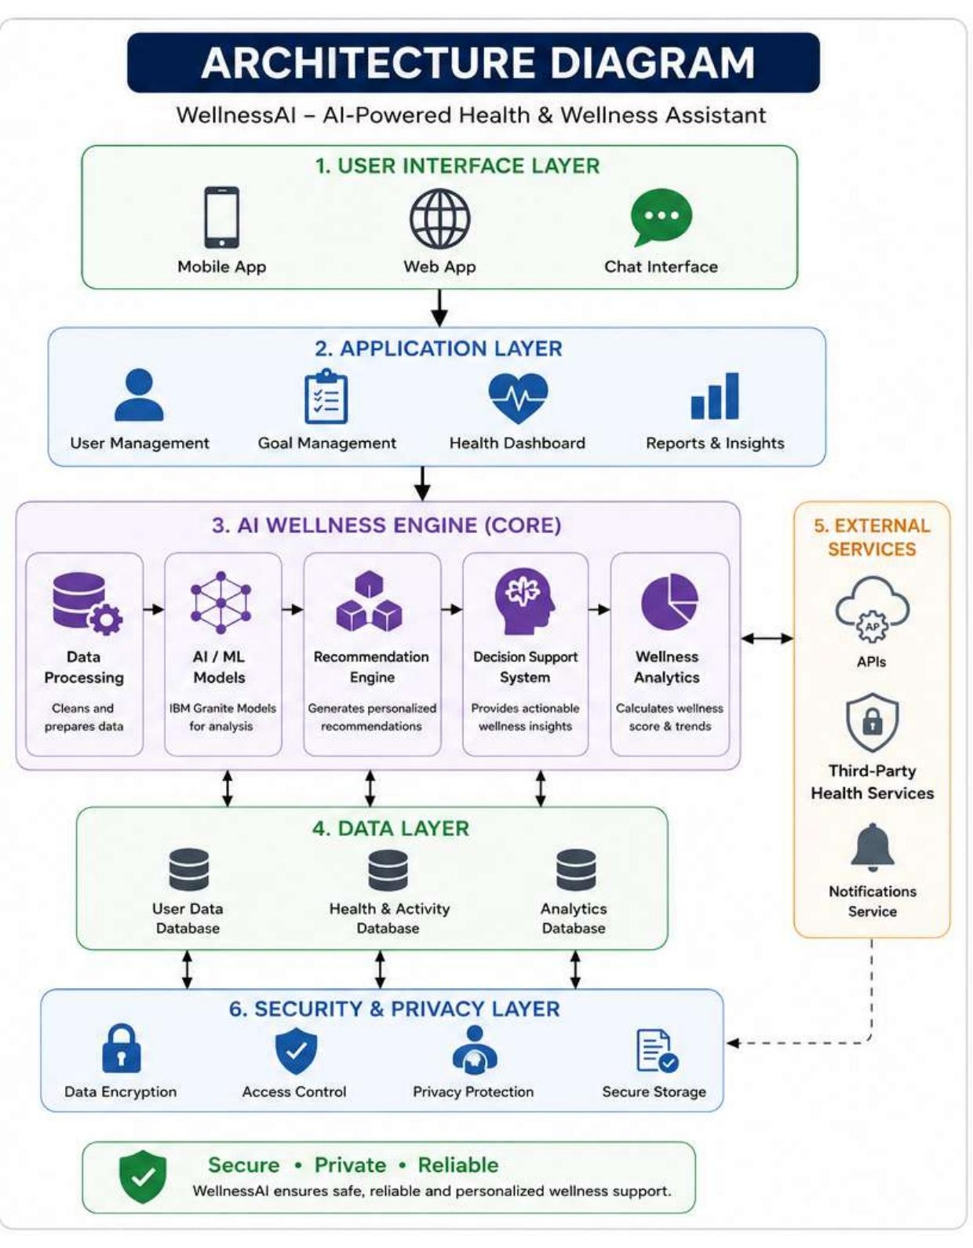
Figure 1: Wellness-AI System Architecture Diagram

5.1 User Interface Layer
The entry point for users, supporting three access modes:
- Mobile App
- Web App
- Chat Interface

5.2 Application Layer
Handles the core application logic and user-facing functionality:
- User Management
- Goal Management
- Health Dashboard
- Reports & Insights

5.3 AI Wellness Engine (Core)
The heart of the system, where raw user data is transformed into personalized guidance:
- Data Processing – cleans and prepares incoming data
- AI/ML Models – IBM Granite models used for analysis
- Recommendation Engine – generates personalized recommendations
- Decision Support System – provides actionable wellness insights
- Wellness Analytics – calculates wellness score and trends

5.4 Use of IBM Technologies
IBM BOB
- Serves as the application integration and workflow management platform.
- Manages user interactions and recommendation workflows.
- Connects Wellness-AI with AI services and models.
IBM Granite
- Processes user wellness information such as age, height, weight, activity level, and fitness goals.
- Analyzes user data to generate personalized recommendations.
- Creates customized workout, nutrition, hydration, and sleep plans.
- Supports conversational AI interactions and wellness guidance.
Integration in Wellness-AI
User wellness data is collected through the application and processed by the AI Wellness Engine. IBM Granite analyzes the information and generates personalized recommendations, while IBM BOB facilitates workflow management and AI integration. Together, these technologies enable Wellness-AI to deliver intelligent and personalized wellness support.

5.5 Data Layer
Persists all user and analytics data across three dedicated stores:
- User Data Database
- Health & Activity Database
- Analytics Database

5.6 External Services
The AI Wellness Engine connects bi-directionally with external services to extend functionality:
- APIs
- Third-Party Health Services
- Notifications Service

5.7 Security & Privacy Layer
Underpins the Data Layer and integrates with external notification services to keep user information safe:
- Data Encryption
- Access Control
- Privacy Protection
- Secure Storage
Together, these layers ensure that WellnessAI remains secure, private, and reliable while delivering personalized wellness support.
6. Workflow
The Wellness-AI user journey follows an eight-step cycle, starting from account creation and ending in a continuous feedback loop that improves future recommendations.
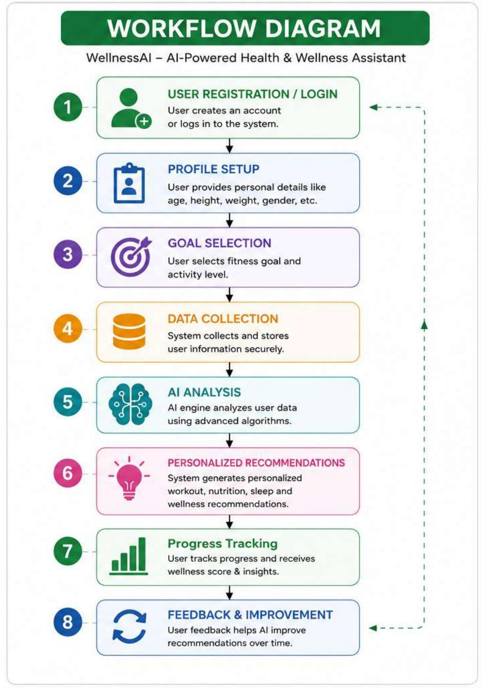
Figure 2: WellnessAI Workflow Diagram
Step | Stage | Description
1 | User Registration / Login | User creates an account or logs in to the system.
2 | Profile Setup | User provides personal details like age, height, weight, gender, etc.
3 | Goal Selection | User selects fitness goal and activity level.
4 | Data Collection | System collects and stores user information securely.
5 | AI Analysis | AI engine analyzes user data using advanced algorithms.
6 | Personalized Recommendations | System generates personalized workout, nutrition, sleep, and wellness recommendations.
7 | Progress Tracking | User tracks progress and receives wellness score & insights.
8 | Feedback & Improvement | User feedback helps the AI improve recommendations over time, looping back into the cycle.

This closed-loop design — where Step 8 feeds back into Step 1's ongoing engagement — allows the AI engine to continuously refine its recommendations as more user data and feedback become available.

7. Prototype
The prototype demonstrates the core user flow: from a welcoming home screen, through profile and goal setup, to a fully generated personalized wellness plan.

7.1 Welcome / Home Screen
Introduces the Wellness-AI brand and value proposition, with clear “Get Started” and “Learn More” calls to action, alongside a persistent AI assistant shortcut.
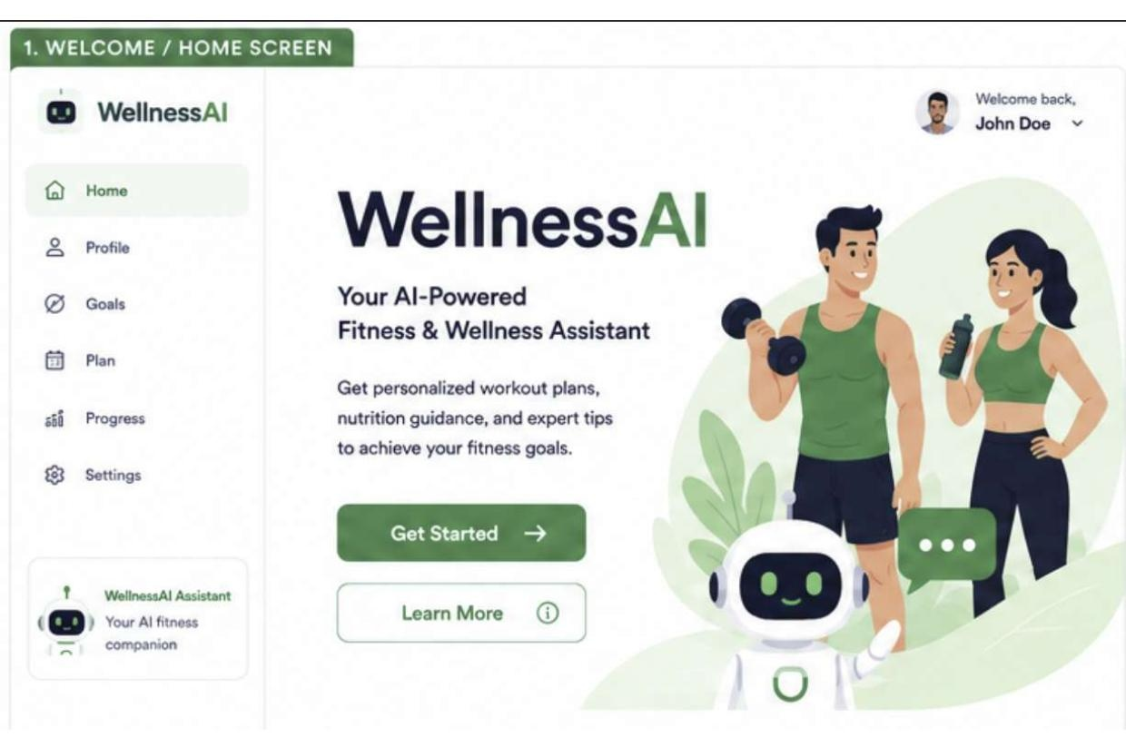
Figure 3: Welcome / Home Screen

7.2 User Profile Screen
Captures core biometric details — name, age, height, weight, and gender — as the first step of a four-stage onboarding flow (Profile → Goals → Plan → Complete).
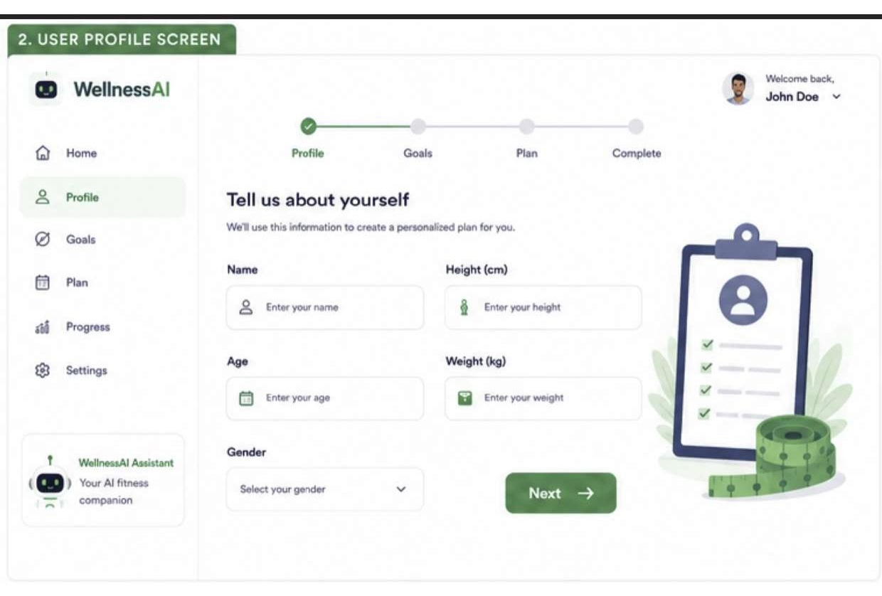
Figure 4: User Profile Screen

7.3 Fitness Goals Screen
Let the user choose a primary goal (Weight Loss, Weight Gain, Muscle Building, or General Fitness) and an activity level (Beginner, Intermediate, or Advanced) before generating a plan.
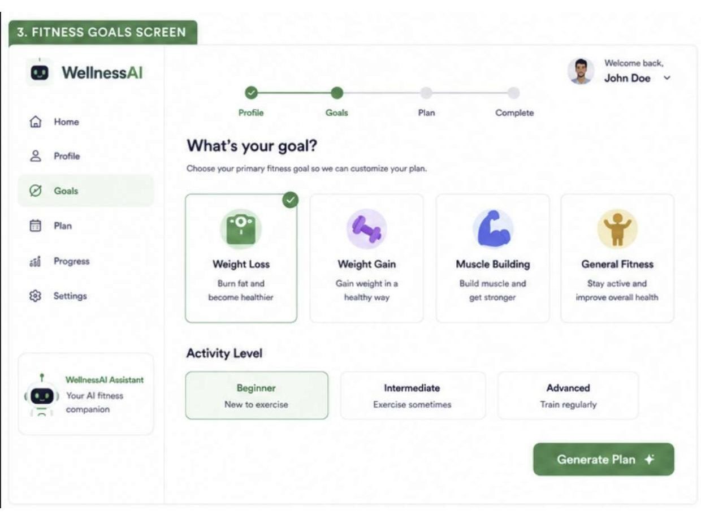
Figure 5: Fitness Goals Screen

7.4 AI Recommendation / Plan Screen
Presents the completed, personalized wellness plan: a weekly workout schedule, nutrition guidelines, a sleep target, daily reminders, and a motivational prompt — with a direct path into progress tracking.
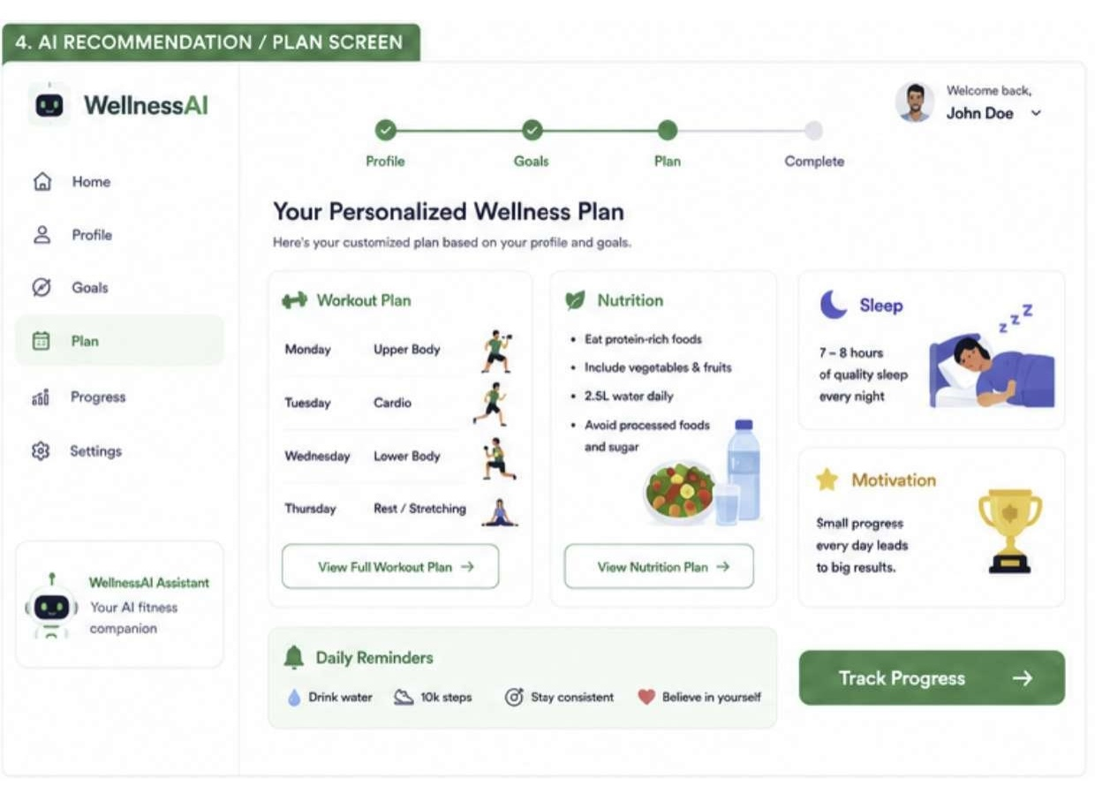
Figure 6: AI Recommendation / Plan Screen

8. Responsible AI Considerations
Wellness-AI is designed with responsible AI principles embedded throughout the product, not added as an afterthought:
Principle | How It's Applied
Fairness | Recommendations are provided equally to all users.
Transparency | AI-generated suggestions are clearly explained.
Privacy | User health information is protected.
Ethics | The system provides guidance and does not replace medical professionals.

9. Expected Impact

9.1 Individual Impact
- Improved fitness habits
- Better nutrition awareness
- Improved sleep quality

9.2 Social Impact
- Increased health awareness
- Healthier communities

10. Conclusion & Future Scope

10.1 Conclusion
Wellness-AI demonstrates how artificial intelligence can be used to improve personal health and wellness through personalized recommendations and guidance. By combining a structured onboarding experience with an AI-driven recommendation engine, the solution makes credible wellness support more accessible, affordable, and sustainable for students and young adults.

10.2 Future Scope
- Smartwatch integration
- Voice-based AI assistant
- Real-time health monitoring
- Advanced wellness analytics
- Mental wellness support

11. Project Details
Project Title | Wellness-AI – AI-Powered Health, Fitness & Wellness Assistant
Submitted By | Pratheeksha N
Institution | Gandhi Institute of Technology and Management
SDG Alignment | SDG-3: Good Health and Well-Being
Core AI Models | IBM Granite Models

